1. **Open AEM in debug mode**

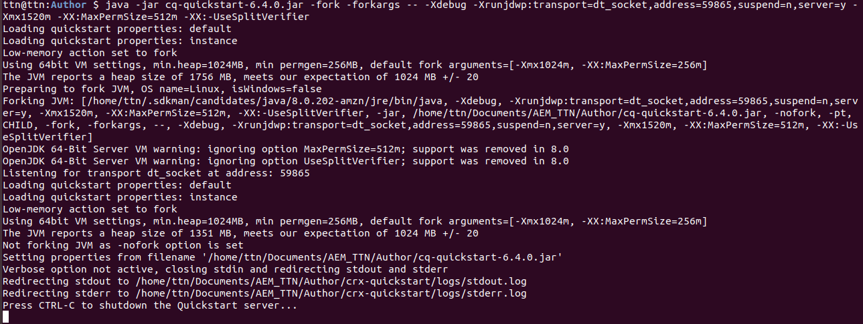

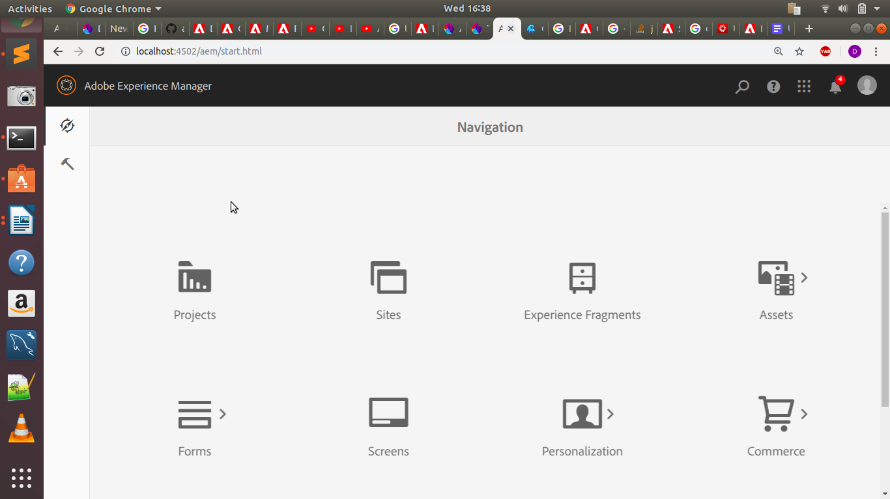

**2. How to identify if AEM is Publish or Author?**

**i). Got to the below mentioned url to find out the AEM Status** [**http://localhost:4502/system/console/status-slingsettings**](http://localhost:4502/system/console/status-slingsettings)

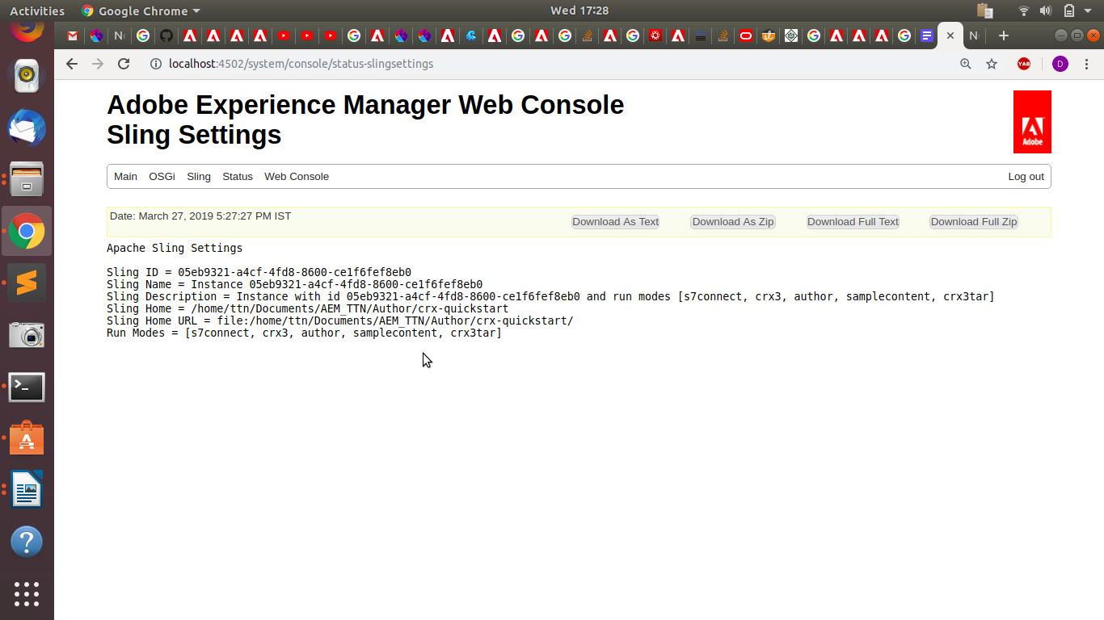

**<%**

**pageContext.setAttribute("runModes",**

**sling.getService(SlingSettingsService.class).getRunModes().toString());**

**%>**

## **Solution**

**You can use the following code in your components and templates to find out if the running instance is an author or a publish**

**DeliveryHttpServletRequest cqRequest = (DeliveryHttpServletRequest) request;**

**// flag to indicate whether instance is Author or Publish boolean isAuthor = !cqRequest.getCmsService().getDisplayControlSet(cqRequest).equals(DisplayControlSet.SHOW);**

**// flag to indicate whether instance is in preview/show mode boolean isShowMode = (cqRequest.getCmsService().getDisplayControlSet(cqRequest).equals(DisplayControlSet.SHOWMODE) || "ShowMode".equals(cqRequest.getParameter("Show")) );**

**This method is better than checking the URL, because this code does nor rely on a specific context, which can change. Also, the author server can be switched to a publish mode by setting parameter "Show" to 1 in the request. So, the request to /author/somepage.html?Show=1 renders as publish. Therefore, relying on the context is not a reliable solution.**

**3. a). Where are all the bundles installed in AEM resides in system?**

**Ans. All the bundles installed in AEM resides in system at the location:**

**crx-quickstart/launchpad/felix**

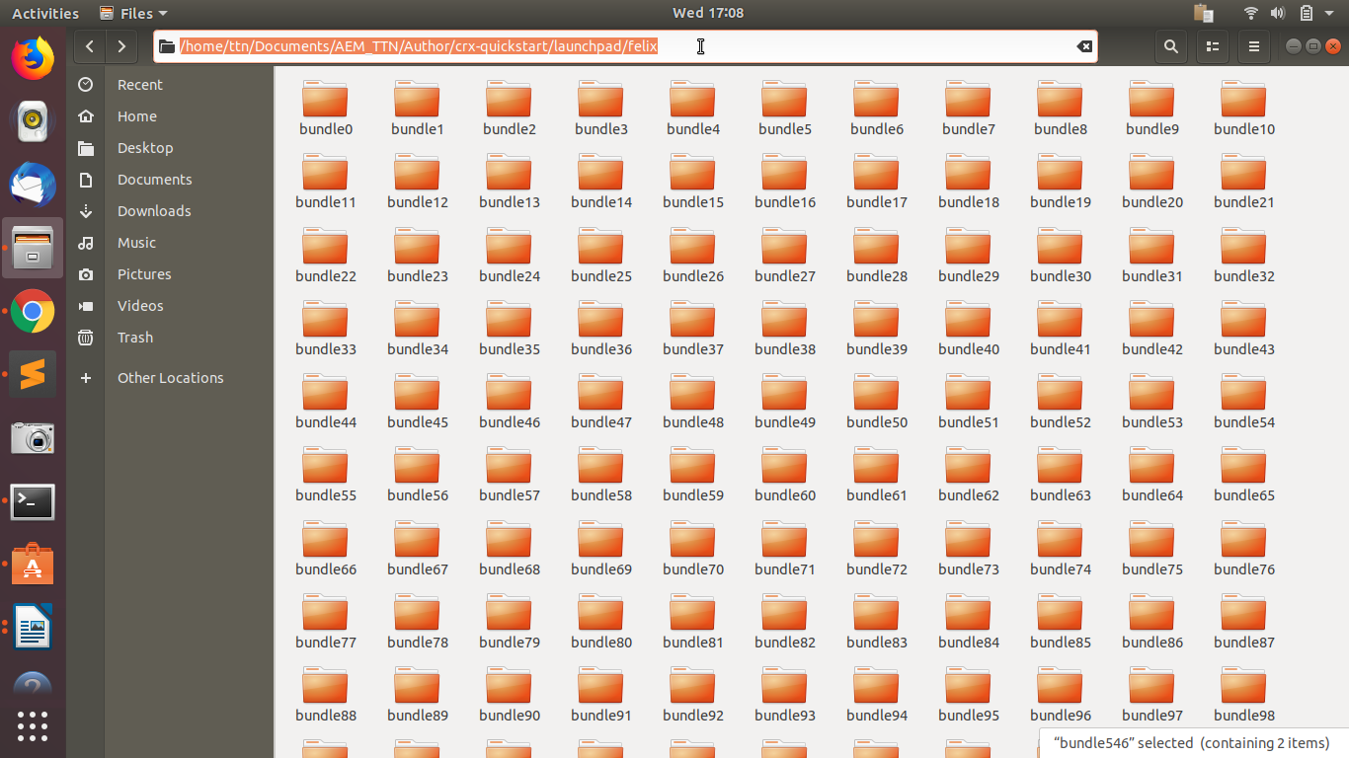

**b). Search for bundle “*com.adobe.granite.ui.clientlibs” and decompile it***

i) Search for com.adobe.granite.ui.clientlibs in

<http://localhost:4502/system/console/bundles>

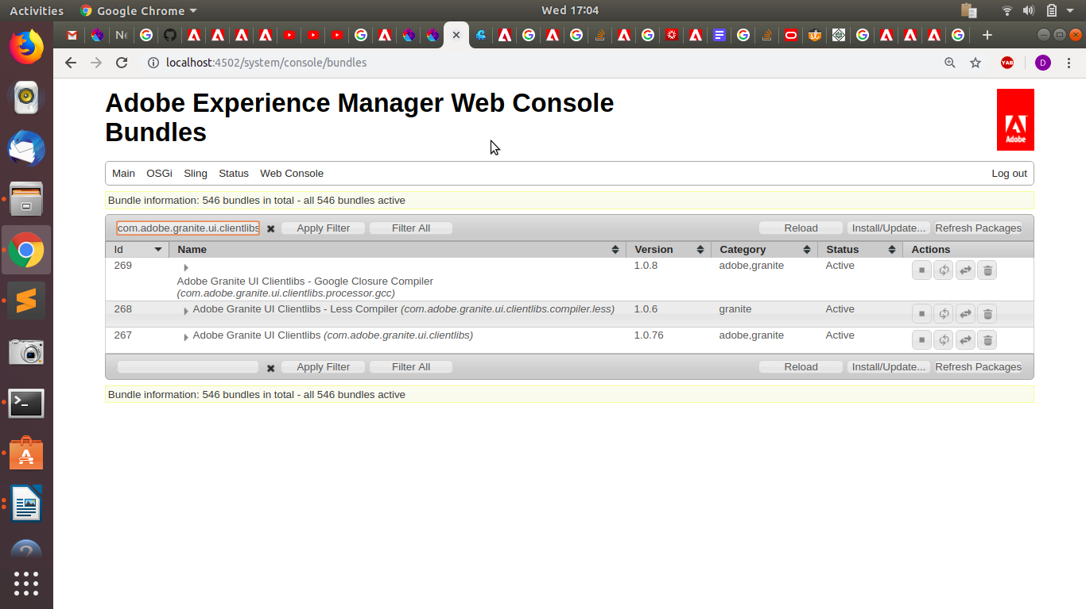

**ii) Now search for bundle 267 in crx-quickstart/launchpad/felix**

**iii) Search for:**

**crx-quickstart/launchpad/felix/bundle267/version0.0 /com/adobe/granite/ui/clientlibs/**

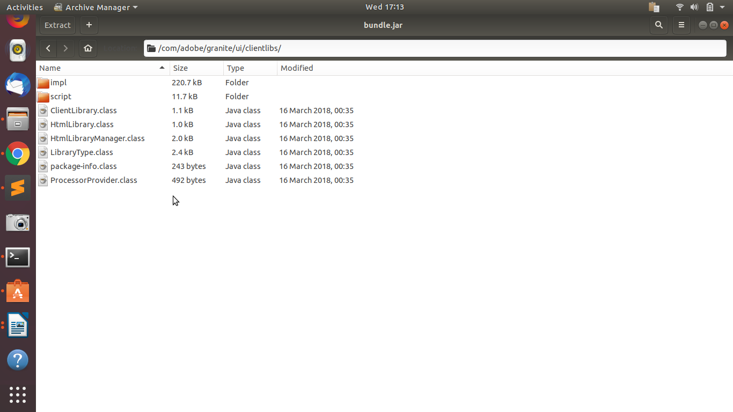

***4. How can we specify in the command line the ‘port’ and ‘host’ while installing the project.***



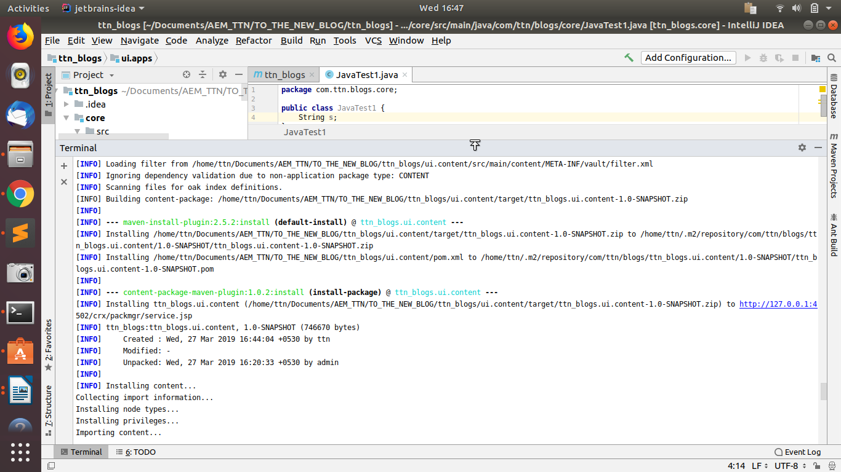

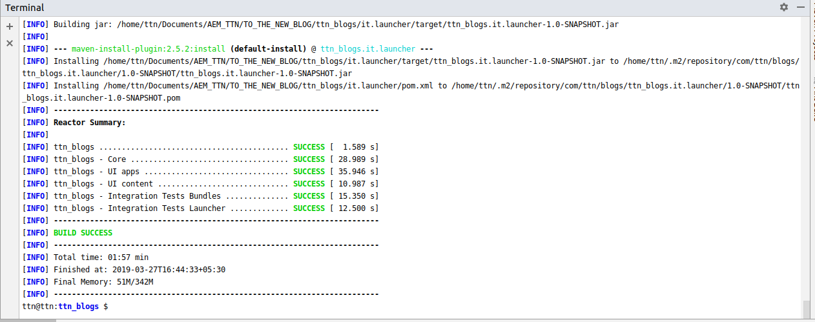

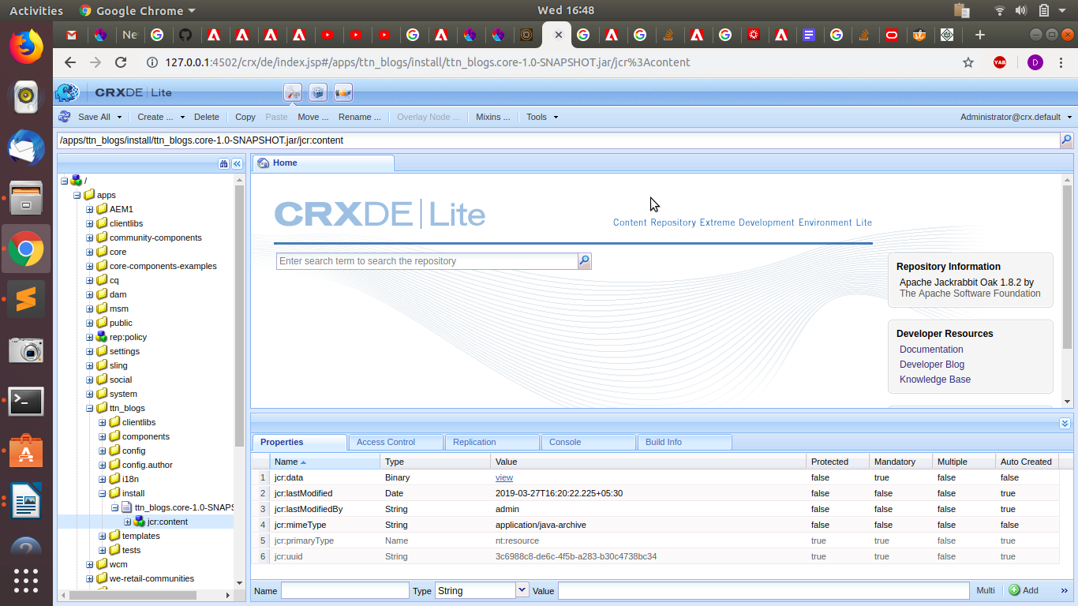

***5. Why do we specify SNAPSHot in the project version?***

***Snapshot is a special version which indicates the current development copy of the project which is being worked on. For each build, maven always checks out for a SNAPSHOT of the project.***

***Hence, whenever maven finds a newer SNAPSHOT of the project, it downloads and replaces the older .jar file of the project in the local repository***

***A snapshot version in Maven is one that has not been released.***

***The idea is that before a 1.0 release (or any other release) is done, there exists a 1.0-SNAPSHOT. That version is what might become 1.0. It's basically "1.0 under development". This might be close to a real 1.0 release, or pretty far (right after the 0.9 release, for example).***

***The difference between a "real" version and a snapshot version is that snapshots might get updates. That means that downloading 1.0-SNAPSHOT today might give a different file than downloading it yesterday or tomorrow.***

***Usually, snapshot dependencies should only exist during development and no released version (i.e. no non-snapshot) should have a dependency on a snapshot version.***

[***https://docs.oracle.com/middleware/1212/core/MAVEN/maven_version.htm#MAVEN402***](https://docs.oracle.com/middleware/1212/core/MAVEN/maven_version.htm#MAVEN402)